Author: Frithjof Eckhardt, updated: 25. Okt. 2013

**Note**: The package comes with the namespace /UKW/, which is the namespace for Wuerzburg University Hospital, Germany. You can’t create objects in this namespace in your SAP system. Therefore map the namespace prefix of each object from /UKW/ to any name starting with Z or Y, or your own customer namespace.

Installation

1. Package ZADSADI
2. Function Group ZADSADI
3. Function Module Z_ADSADI with one screen 100 carrying a custom control
4. Create dictionary objects for storing html content
5. Interface ZIF_ADSADI_CALLBACK
6. Class ZCL_ADSADI_DIALOG

# Create new Package, e.g. ZADSADI

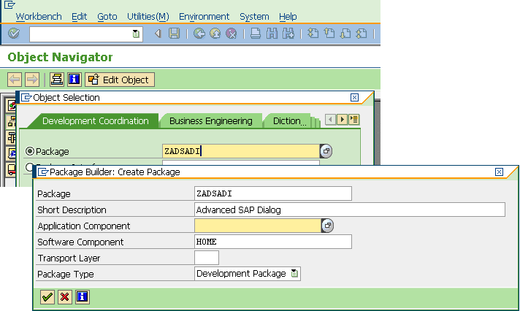

# Within the package create and activate Function Group, e.g. ZADSADI

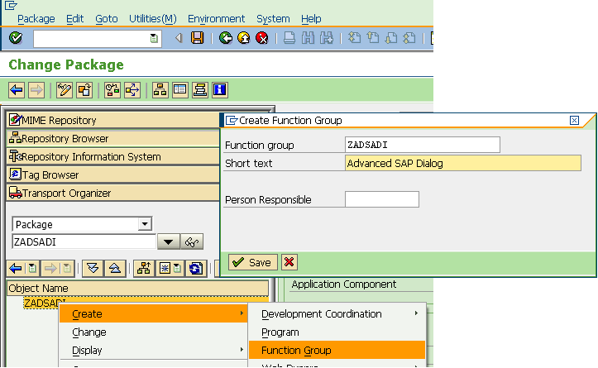

# Within the function group create Function Module, e.g. Z_ADSADI

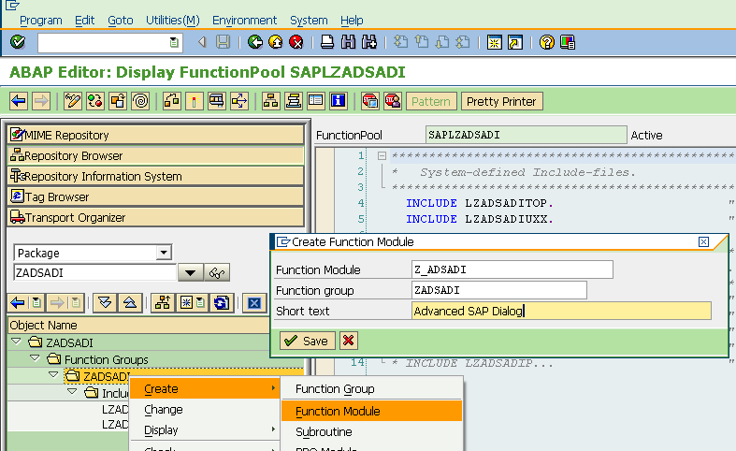

### Add the following line to the source code of the function module and activate

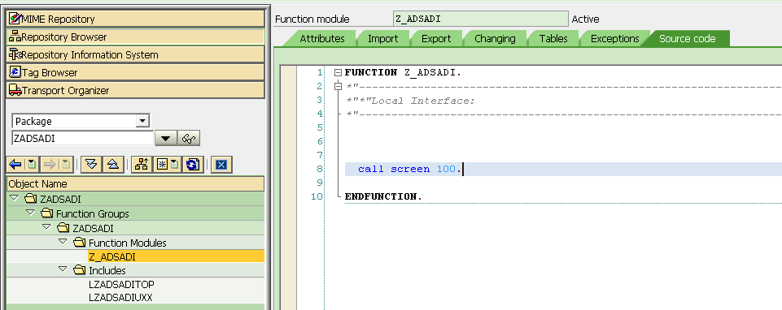

### Create screen 100 by double clicking the „100“ in the source code:

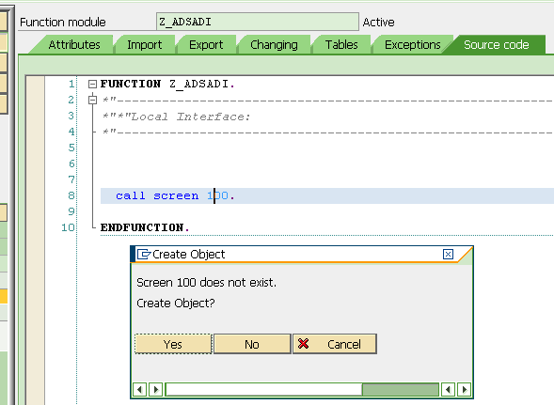

### Set the screen type to „Modal dialog box“ and activate

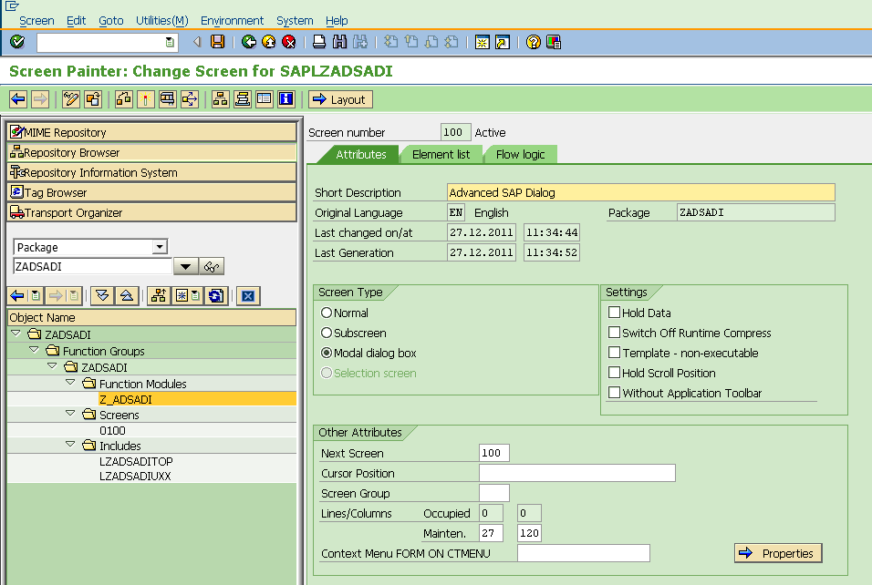

### Create the layout for the screen

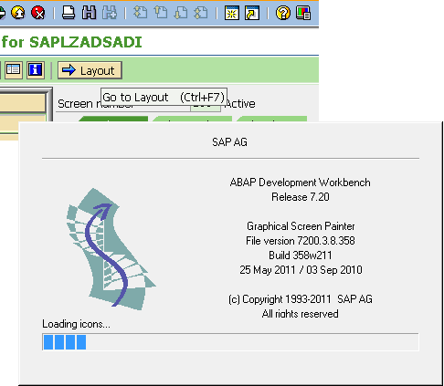

### Create a custom control screen element

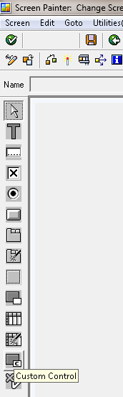

### Set the name of the control to „CONTAINER“

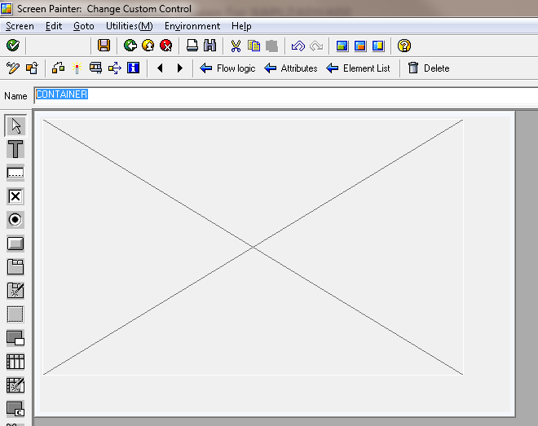

### Resize the window below the container so that it is a little greater than the screen size of the target monitor , e.g. 186 columns, 36 rows for 19“ monitor (trial&error determined)

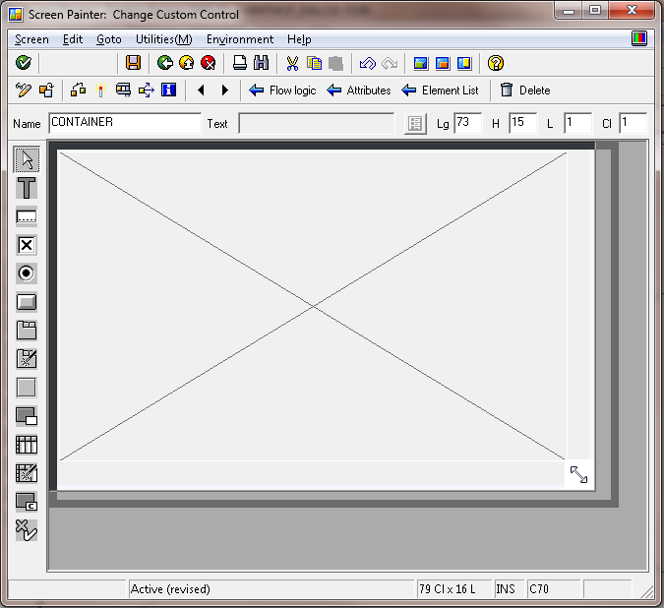

### Set the dimension of the container to the same size as the underlying window and link both together by setting the resizing attributes of the container and activate

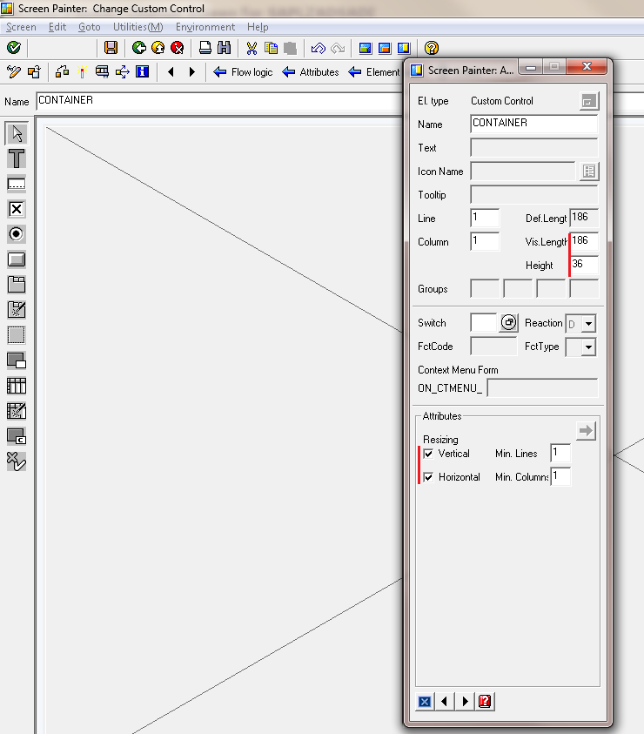

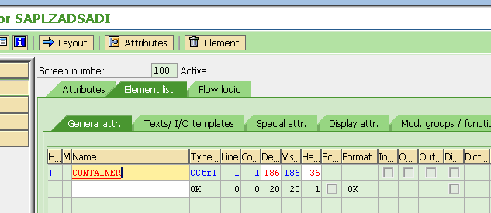

### Edit the top include of the function module and enter the following data definitions

data: html_control type ref to cl_gui_html_viewer.  
data: container type ref to cl_gui_custom_container.

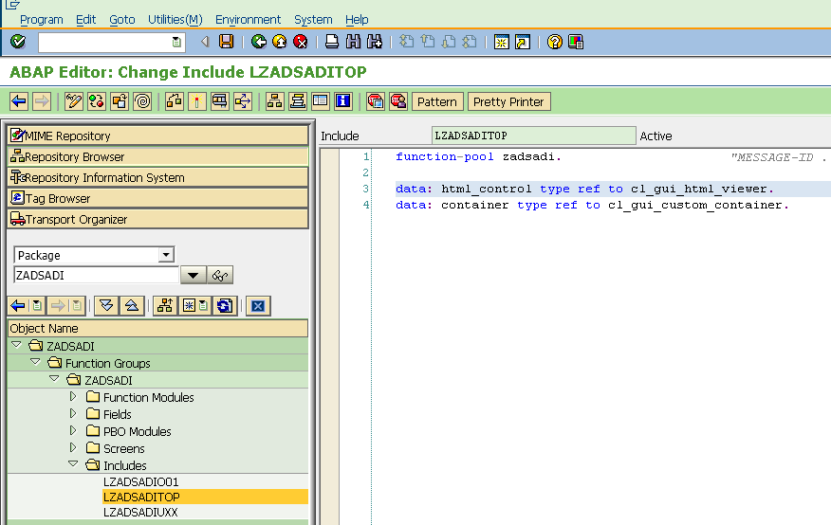

### Create Flow logic of the screen for „PROCESS BEFORE OUTPUT“ by uncommenting the respective module call and creating the source code by clicking twice on the module name „STATUS_0100“

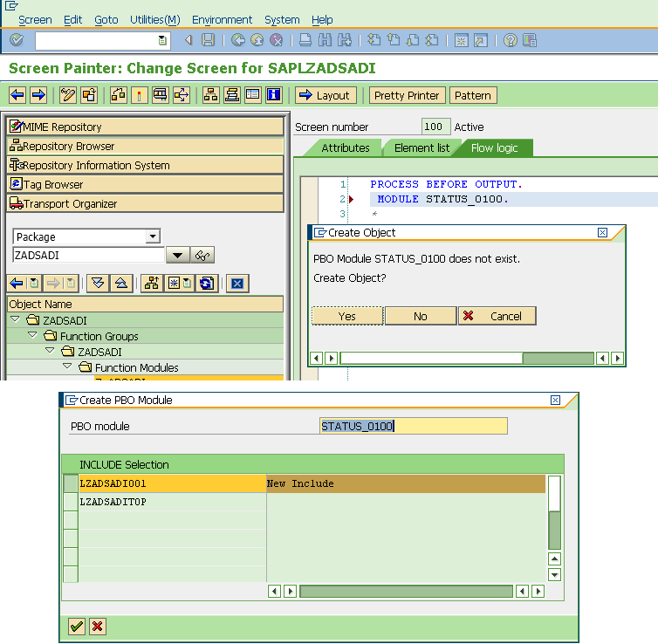

### Enter the following code

module status_0100 output.  
  set pf-status 'ZADSADI'.  
* SET TITLEBAR 'xxx'.  
  if html_control is initial.  
    create object container  
      exporting  
        container_name = 'CONTAINER'.  
  
    create object html_control  
      exporting  
        parent = container.  
  endif.  
endmodule.

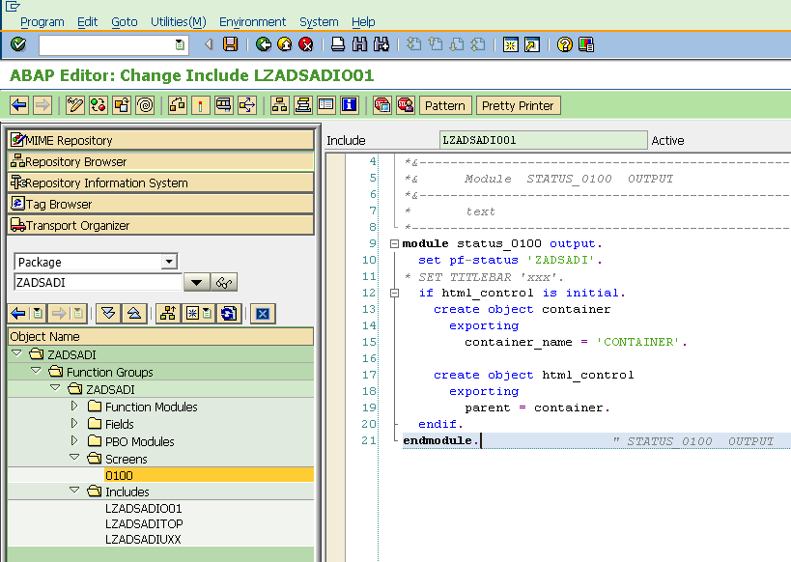

### In the same include, create Flow logic of the screen for „PROCESS AFTER INPUT“ by uncommenting the respective module call and creating the source code by clicking twice on the module name „USER_COMMAND_0100“

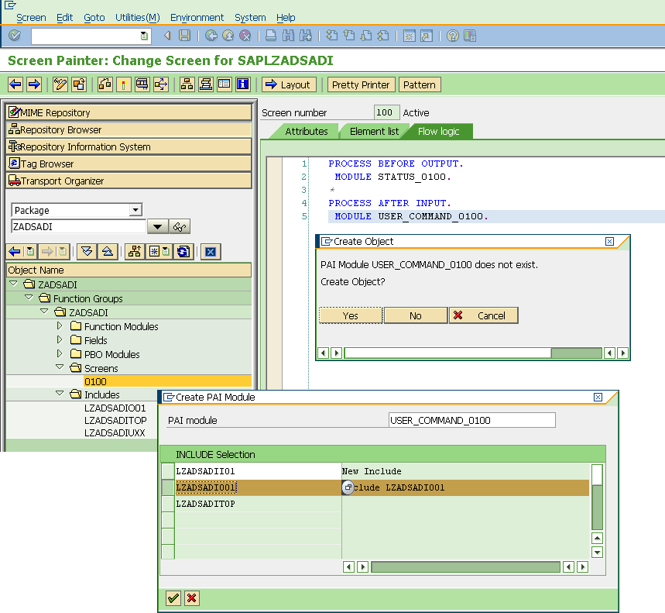

### Enter the following code

module user_command_0100 input.  
  case sy-ucomm.  
    when 'BACK'.  
      if not html_control is initial.  
        call method html_control->free.  
        free html_control.  
        call method container->free.  
        free container.  
      endif.  
      leave to screen 0.  
    when others.  
      call method cl_gui_cfw=>dispatch.  
  endcase.  
endmodule.

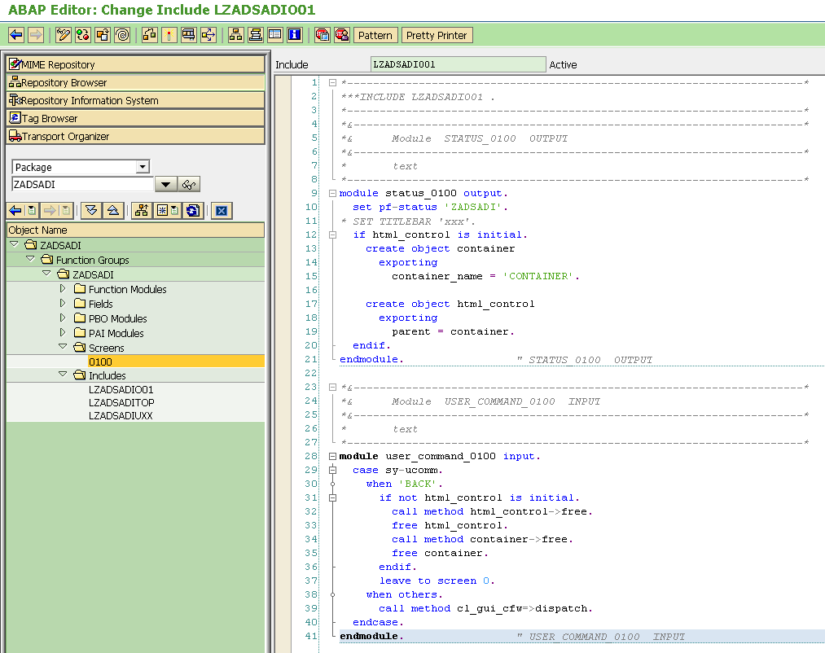

### Create the GUI status by double-clicking on the „ZADSADI“ in the status_0100 module in the line „set pf-status 'ZADSADI'

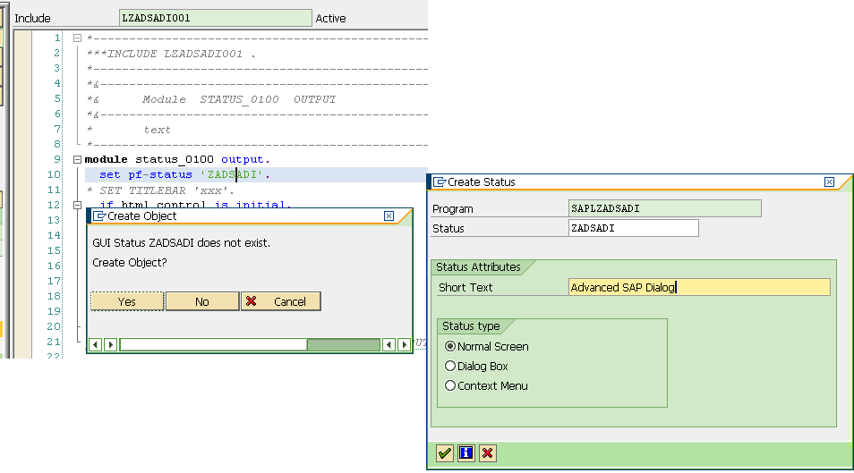

### Enter the function code „BACK“ for all the navigation buttons (back, exit, cancel) in the toolbar section and activate the status

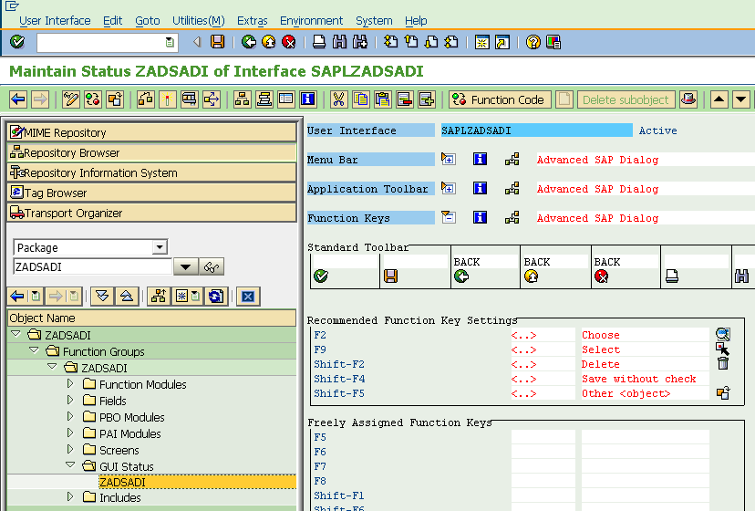

### Test the screen by testing the function module

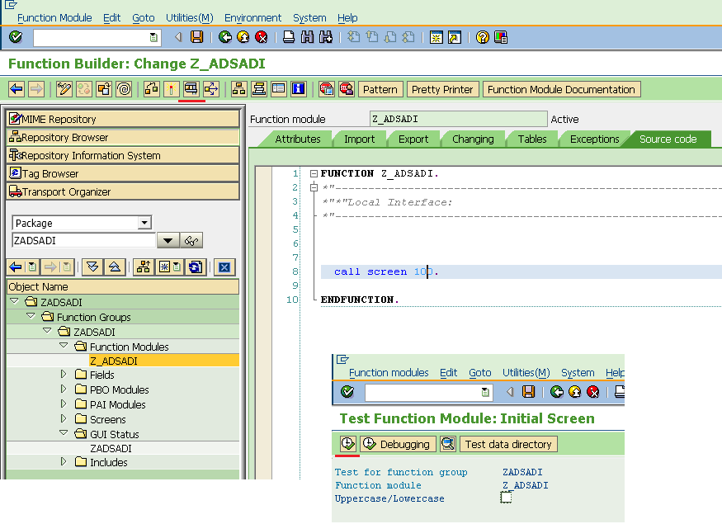

A white window appears, that is resizeable and any navigation button brings the user back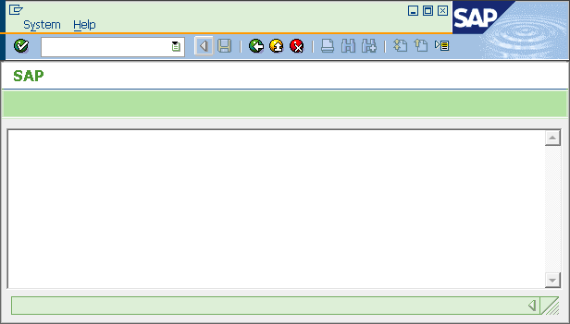

The white window is an html page, verify it by hiting the right mouse button to show the Internet Explorer context menu

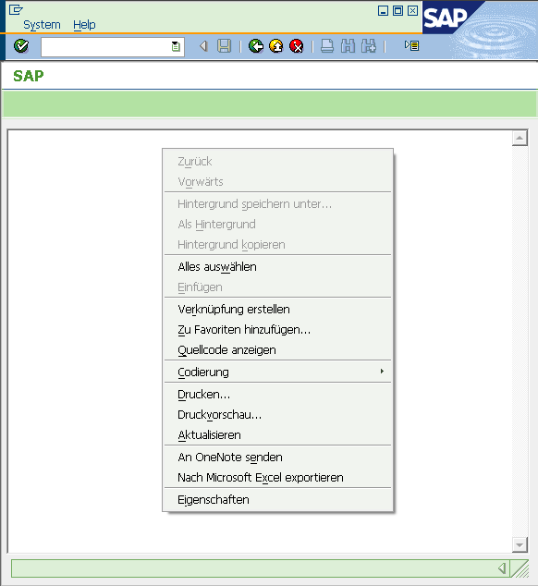

Create the backing logic

# Create a data element ZADSADI_ML for storing a line of html markup

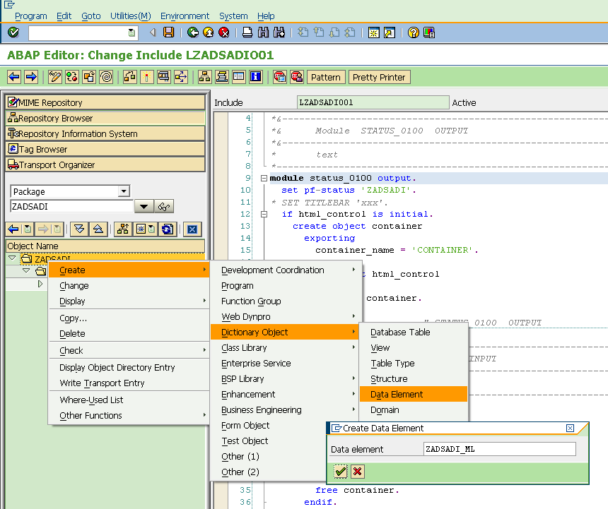

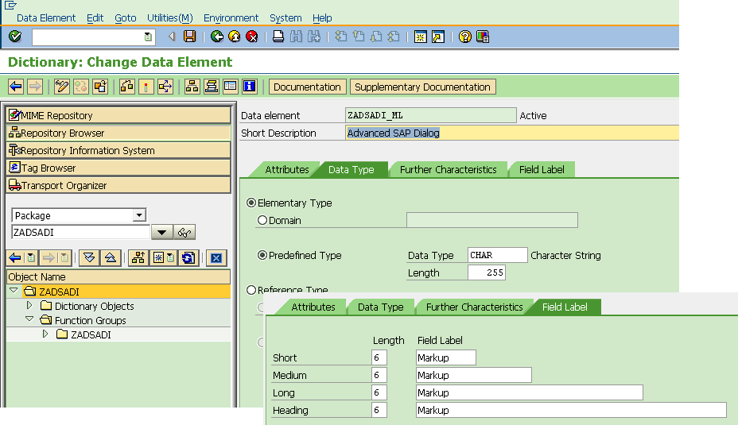

# Create a table type ZADSADI_T_ML for html content

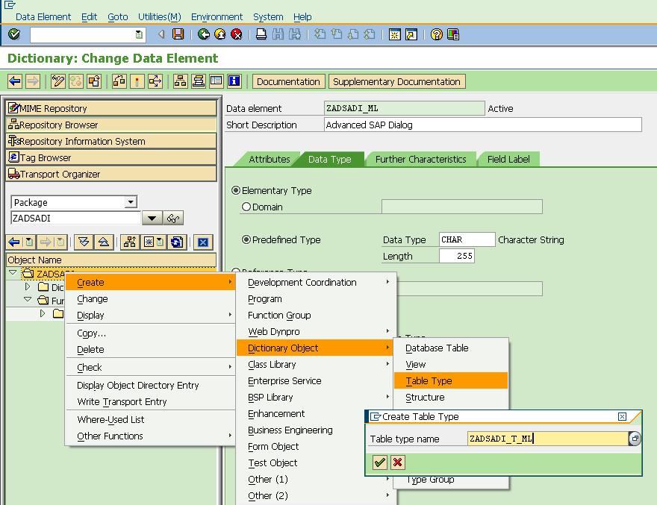

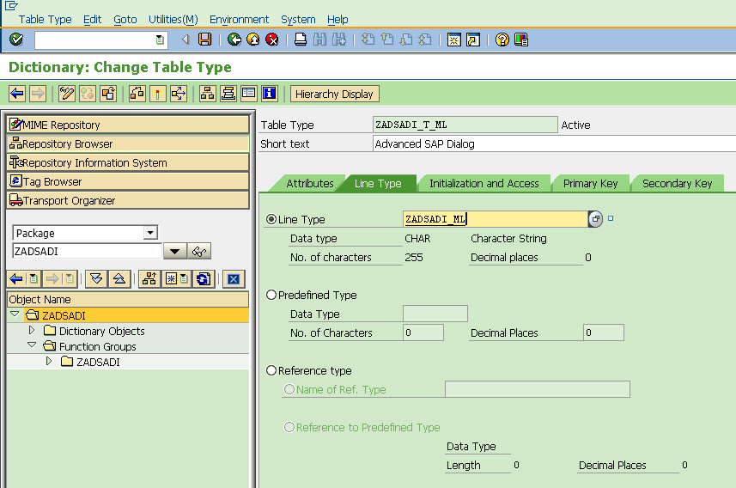

# Create an interface ZIF_ADSADI_CALLBACK

This interface is used from within the screen 100 implementation to get the html content to be displayed and to provide the parameters returned from the html viewer.

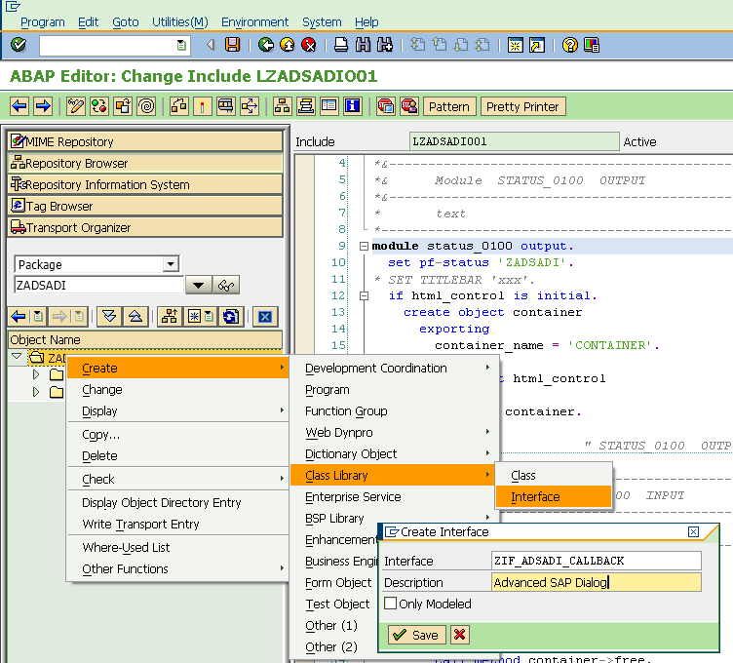

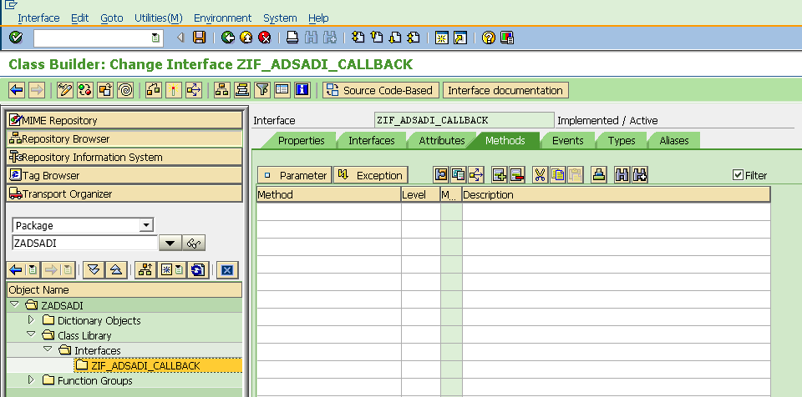

Switch to „Source Code-Based“ view of the class builder. If this button is not available (due to an older release), create the methods the traditional way one at a time with the class builders help.

In the source code-based view, enter the following interface code and switch back to „Form-based“ view.

interface zif_adsadi_callback public.  
  
  type-pools cnht.

  constants dlg_cancel type i value 1.                       
  constants dlg_no_cancel type i value 0.                    
  
  methods action_post  
    importing  
      value(action) type c  
      value(getdata) type c optional  
      value(postdata) type cnht_post_data_tab  
      value(query_table) type cnht_query_table optional .  
  methods create_view  
    returning  
      value(r) type zadsadi_t_ml.  
  
endinterface.

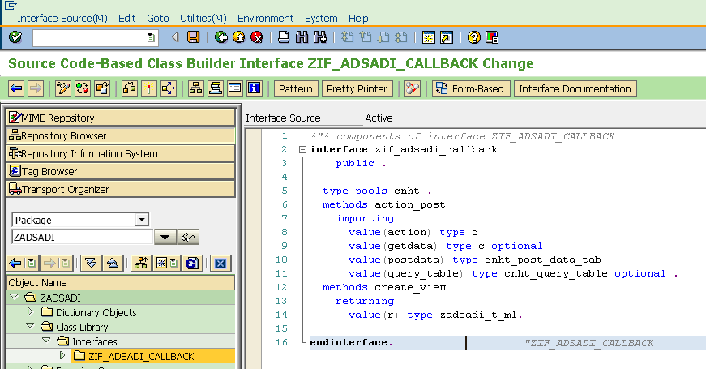

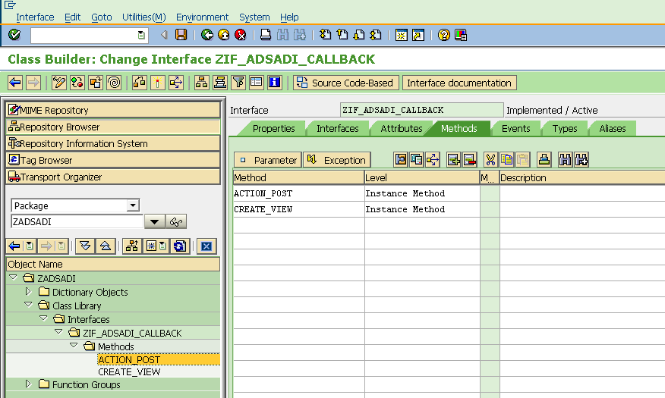

# Create an implementation ZCL_ADSADI_DIALOG against this interface

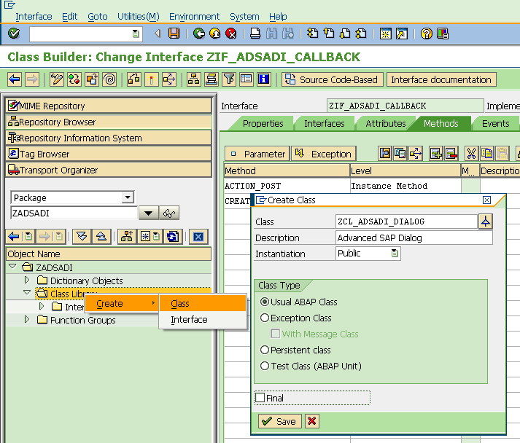

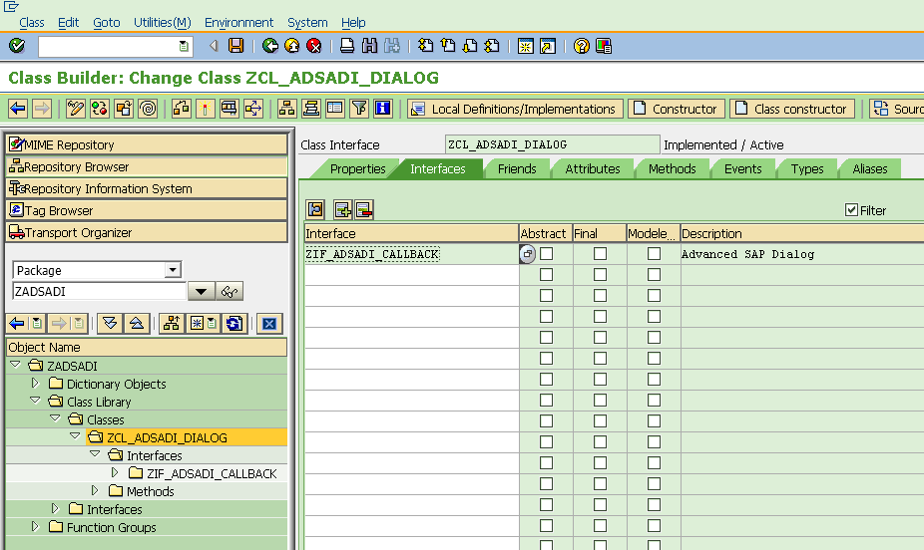

Switch to „Source Code-based“ view and edit the source code the following way:

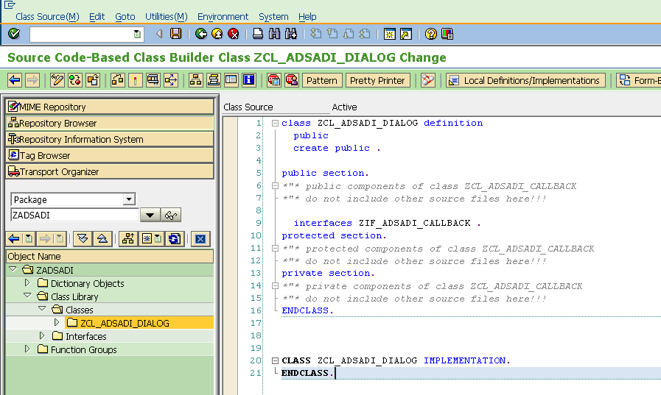

## Public section

    interfaces zif_adsadi_callback .  
  
    aliases create_view  
      for zif_adsadi_callback~create_view.  
    aliases do_post  
      for zif_adsadi_callback~action_post.  
  
    type-pools abap.   
    type-pools cnht.  
  
    methods constructor  
      importing  
        value(i_xslt) type csequence  
        value(i_xml) type csequence optional  
        value(i_xml_doc) type ref to if_ixml_node optional  
        value(i_params) type abap_trans_parmbind_tab optional  
        value(i_size) type csequence default ''  
        value(i_top_left_y) type i default 3  
        value(i_top_left_x) type i default 40  
        value(i_width) type i default 100  
        value(i_height) type i default 25.  
    methods get_value  
      importing  
        value(n) type csequence  
      returning  
        value(r) type string .  
    methods render  
      returning  
        value(canceled) type i .

## Protected section

    data xml type string .  
    data xml_doc type ref to if_ixml_node .

## Private section

    data xslt type string.  
    data xslt_params type abap_trans_parmbind_tab.  
    data query_table type cnht_query_table.  
    data size type string.  
    data top_left_y type i.  
    data top_left_x type i.  
    data width type i.  
    data height type i.

## Constructor implementation

  method constructor.  
    me->xslt_params  = i_params.  
    me->xslt         = i_xslt.  
    me->size         = i_size.  
    me->top_left_y   = i_top_left_y.  
    me->top_left_x   = i_top_left_x.  
    me->width        = i_width.  
    me->height       = i_height.  
    if i_xml is not initial.  
      me->xml = i_xml.  
    elseif i_xml_doc is bound.  
      me->xml_doc = i_xml_doc.  
    else.  
      concatenate  
        `<?xml version="1.0" encoding="utf-8" ?>`  
        `<dialog />`  
        into me->xml.  
    endif.  
  endmethod.

## Method get_value implementation

  method get_value.  
    data: the_param type w3query.  
  
    loop at me->query_table into the_param where name eq n.  
      r = the_param-value.  
      exit.  
    endloop.  
  endmethod.

## **Method** render **implementation**

  method render.  
    call function 'Z_ADSADI'  
      exporting  
        i_callback   = me  
        i_size       = me->size  
        i_top_left_y = me->top_left_y  
        i_top_left_x = me->top_left_x  
        i_width      = me->width  
        i_height     = me->height  
      importing  
        e_canceled   = canceled.  
  endmethod.

## Modify the interface of the function module to match the call from the render Method

## Import

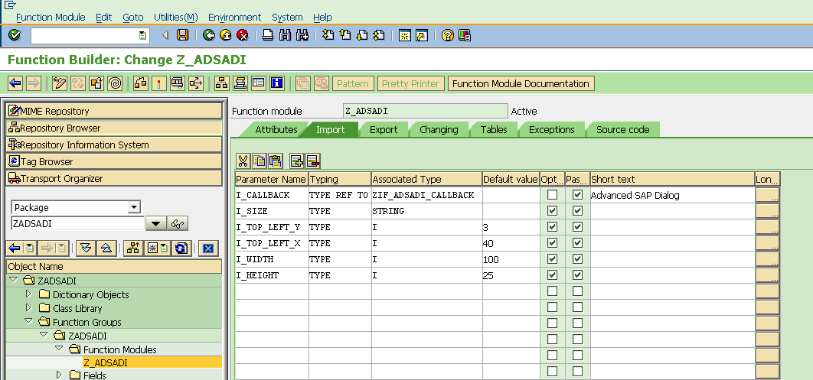

## Export

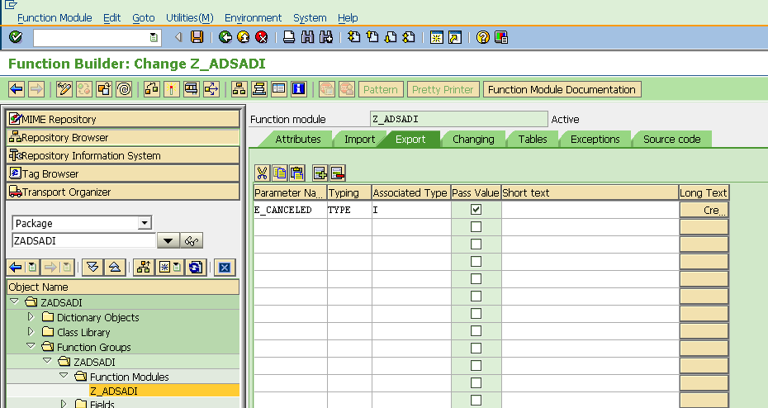

## Source code function module Z_ADSADI

  g_callback = i_callback.  
  g_canceled = zif_adsadi_callback=>dlg_cancel.  
  
  if i_size eq 'NORMAL'.  
    call screen 100  
      starting at 40  3  
      ending   at 140 30.  
  elseif i_size eq 'FULL'.  
    call screen 100.  
  else.  
    data: bottom_right_x type i.  
    data: bottom_right_y type i.  
  
    bottom_right_x = i_top_left_x + i_width.  
    bottom_right_y = i_top_left_y + i_height.  
    call screen 100  
      starting at i_top_left_x   i_top_left_y  
      ending   at bottom_right_x bottom_right_y.  
  endif.  
  
  e_canceled = g_canceled.

## Source code top include of function module Z_ADSADI

function-pool zadsadi.                      "MESSAGE-ID ..  
  
data: html_control type ref to cl_gui_html_viewer.  
data: container type ref to cl_gui_custom_container.  
  
data: g_callback type ref to zif_adsadi_callback.  
data: g_canceled type i.

# Test the dialog implementation

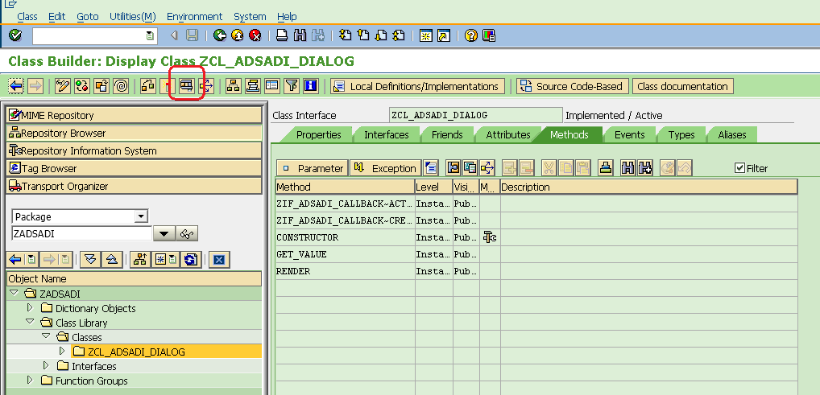

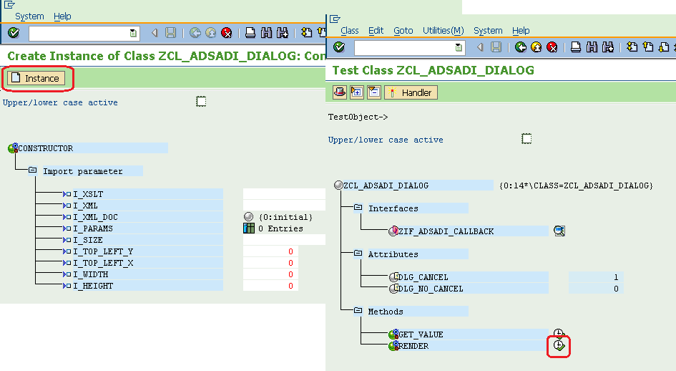

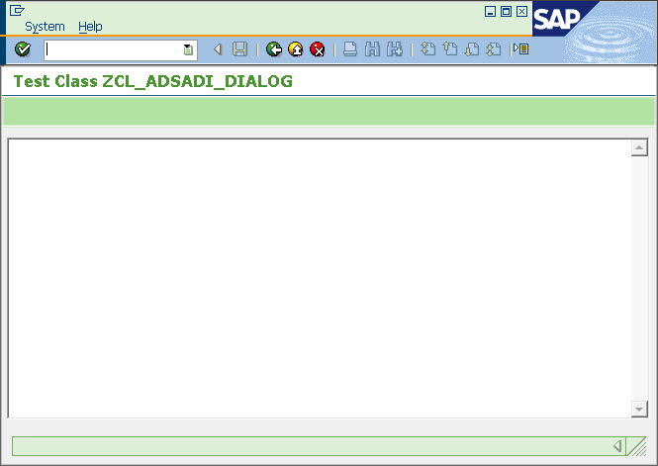

# Back to screen 100, breathe life into it

## Top include

data: myevent_tab TYPE cntl_simple_events.  
data: myevent TYPE cntl_simple_event.

In the module include above status_0100, add an event handler for the HTML Viewer control:

class cl_myevent_handler definition.  
  public section.  
    methods: on_sapevent  
      for event sapevent  
      of cl_gui_html_viewer  
      importing action frame getdata postdata query_table.  
endclass.

class cl_myevent_handler implementation.  
  
  method on_sapevent.  
    if g_callback is bound.  
      call method g_callback->action_post  
        exporting  
          action      = action  
          getdata     = getdata  
          postdata    = postdata  
          query_table = query_table.  
      if action is not initial.  
        g_canceled = zif_adsadi_callback=>dlg_no_cancel.  
      endif.  
      perform close.  
    endif.  
  endmethod.                    "on_sapevent  
endclass.

data: evt_receiver type ref to cl_myevent_handler.

## Refactor out code to destroy the control

module user_command_0100 input.  
  case sy-ucomm.  
    when 'BACK'.  
      perform close.  
    when others.  
      call method cl_gui_cfw=>dispatch.  
  endcase.  
endmodule.

form close.  
  if not html_control is initial.  
    call method html_control->free.  
    free html_control.  
    call method container->free.  
    free container.  
  endif.  
  leave to screen 0.  
endform.

## Add code for event registration and page content loading

module status_0100 output.  
  set pf-status 'ZADSADI'.  
* SET TITLEBAR 'xxx'.  
  if html_control is initial.  
    create object container  
      exporting  
        container_name = 'CONTAINER'.  
  
    create object html_control  
      exporting  
        parent = container.  
  
*   register event  
    myevent-eventid = html_control->m_id_sapevent.  
    myevent-appl_event = 'x'.  
    append myevent to myevent_tab.  
  
    html_control->set_registered_events( myevent_tab ).  
    create object evt_receiver.  
    set handler evt_receiver->on_sapevent for html_control.  
  
    perform load_page_content.  
  endif.  
endmodule.

form load_page_content.  
  data: doc_url(80).  
  data: html_tab type zadsadi_t_ml.  
  data: html_l type line of zadsadi_t_ml.  
  
  refresh html_tab.  
  
  html_tab = g_callback->create_view( ).  
  
  call method html_control->load_data  
    exporting  
      url          = doc_url  
      size         = 0  
      type         = 'text'  
      subtype      = 'html'  
    importing  
      assigned_url = doc_url  
    changing  
      data_table   = html_tab  
    exceptions  
      others       = 1.  
  
  if sy-subrc eq 0.  
    call method html_control->show_url  
      exporting  
        url = doc_url.  
  endif.  
endform.

## Implement ZCL_ADSADI_DIALOG methods derived from interface

### Method action_post

  method zif_adsadi_callback~action_post.  
    data: the_param type w3query.  
    clear: me->query_table.  
    " Gather post and get data  
    if getdata is not initial.  
      the_param-name = action.  
      the_param-value = getdata.  
      append the_param to me->query_table.  
    endif.  
    loop at query_table into the_param.  
      append the_param to me->query_table.  
    endloop.  
  endmethod.

### Method create_view

  method zif_adsadi_callback~create_view.  
    data: ex type ref to  cx_xslt_runtime_error.  
    data: ex2 type ref to cx_transformation_error.  
  
    data: param type abap_trans_parmbind.  
  
    data: begin of bgr,  
          h1 type c length 2,  
          h2 type c length 2,  
          h3 type c length 2,  
        end of bgr.  
  
    data: hex type x length 3.  
    data: buf type c length 10.  
    data: color type i.  
  
*   Background-Color1  
    param-name = 'SAP_BACKGROUNDCOLOR1'.  
    param-value = '#FFFFFF'.  
  
    " Overwrite default with system value  
    call method cl_gui_resources=>get_background_color  
      exporting  
        id     = cl_gui_resources=>col_background_level1  
        state  = 0  
      importing  
        color  = color  
      exceptions  
        others = 1.  
    if sy-subrc = 0.  
      bgr = buf = hex = color.  
      concatenate `#` bgr-h3 bgr-h2 bgr-h1 into param-value.  
    endif.  
    append param to me->xslt_params.  
  
*   Background-Color2  
    param-name = 'SAP_BACKGROUNDCOLOR2'.  
    param-value = '#CCCCCC'.  
  
    " Overwrite default with system value  
    call method cl_gui_resources=>get_background_color  
      exporting  
        id     = cl_gui_resources=>col_background_level2  
        state  = 0  
      importing  
        color  = color  
      exceptions  
        others = 1.  
    if sy-subrc = 0.  
      bgr = buf = hex = color.  
      concatenate `#` bgr-h3 bgr-h2 bgr-h1 into param-value.  
    endif.  
    append param to me->xslt_params.  
  
  
    try.  
        if me->xml_doc is bound.  
          call transformation (me->xslt)  
                   parameters (me->xslt_params)  
                   source xml me->xml_doc  
                   result xml r.  
        else.  
          call transformation (me->xslt)  
                   parameters (me->xslt_params)  
                   source xml me->xml  
                   result xml r.  
        endif.  
      catch: cx_xslt_runtime_error into ex.  
      catch: cx_invalid_transformation into ex2.  
    endtry.  
  endmethod.